VIDHIOTSAV
‘Autumn Edition’ 2019
About Us

University of Petroleum and Energy Studies (UPES) sprawling over a beautiful campus in the capital city of Dehradun was established in the year 2003 through an Act of Legislative Assembly of Uttarakhand. Founded by prominent educationalists and industry experts, UPES is Asia's first University that offers specialized graduate, post graduate and doctoral programs that are specifically designed for core sectors with high growth projections. Recognized as "University with a Purpose", UPES is driven by a progressive vision to create specialized professionals in core sectors, who can contribute in the economic growth of the country. UPES School of Law was born in 2007 with the objective to produce competent and strong legal professionals. Since then it has been a pioneer in grooming modern day legal professionals with a multidisciplinary edge by providing specialization in Corporate Law, Energy Law, Criminal Law, Labor Law, Constitution Law, Taxation Law, Media & Entertainment Law, International Trade & Investment, Banking, Finance & Insurance, IPR, Food, Health & Environment Law, Medical & Forensic Law and Techno- Legal law courses.

About The Fest

VIDHIOTSAV' Autumn edition is the bi -annual law fest to be organized by UPES, School of Law and is scheduled to be held from 26th to 29th September 2019. The fest shall comprise of various academic competitions and events, which will witness the participation of students across law schools in India. 'VIDHIOTSAV' seeks to provide a platform for exchange of ideas and experience between students across Law Schools in India. The events would serve as academic stimulations and harness skills like self -awareness, critical thinking, organizational skills and teamwork, making them better professionals.

Thrilled by the overwhelming response to our first edition of Law Fest, VIDHIOTSAV (SPRING EDITION 2019) wherein more than 300 students and 50 judges from different parts of the country participated, we would like to declare that UPES School of Law is once again coming up with the second edition of Law fest named as ‘VIDHIOTSAV’ (AUTUMN EDITION 2019) from 26th to 29th September, 2019.

Venue

UPES School of Law, Knowledge Acres, P.O. Kandoli, via PremNagar, Dehradun - 248007, Uttarakhand, Tel: 0135-2776061/91, 2776201, 2776053/54

Following Events Are Going To Be Organized:

- IV National Techno Legal-Moot Competition, 2019
- II International Conference on Law and Technology, 2019
- VIII National Parliamentary Debate Competition, 2019
- I National Difficult Dialogue Competition, 2019
- II Surana & Surana and UPES School of Law National Insolvency Law Moot Court Competition, 2019
- VII National Client Counseling Competition, 2019
- V National Youth Parliament Competition, 2019
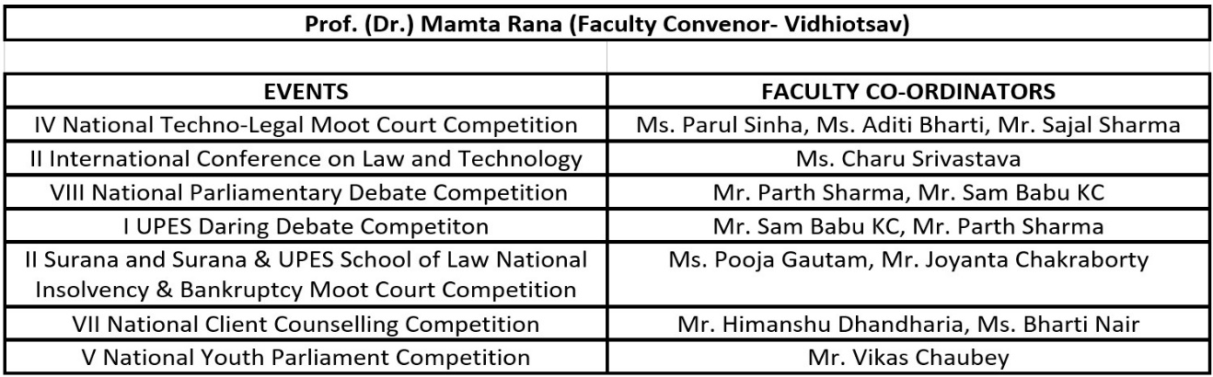

We would like to take this opportunity to invite your University/Institute to participate in various competitions. It would be an honor to have participation from your institution.
Brochure & Poster for out Law Fest, VIDHIOTSAV (Autumn Edition 2019) is attached.
Link for Vidhiotsav (Autumn Edition 2019) Brochure: https://tinyurl.com/BrochureUPES-SoLVidhiotsav2019
Link for Vidhiotsav (Autumn Edition 2019) Poster: https://tinyurl.com/PosterUPES-SoLVidhiotsav2019

For Any Queries And Clarifications Contact:

- Ms. Vaishali Singh
Assistant Professor
+91 7300113446

- Ms. Aishwarya Vats
Assistant Professor
+91 9472936452

- Mr. Anish Yadav
Student Coordinator
+91 8512809700

- Mr. Anuj Karnatak
Student Coordinator
+91 9669776904

Email: upes.sol.vidhiotsav@ddn.upes.ac.in

